
FORM
ON-CALL HOUSEHOLD CLEANUP COLLECTION - UNIT COMPLEX BOOKING CONSENT FORM
Privacy Notification (Privacy and Personal Information Protection Act 1998 – Section 10) - The personal information that Council is collecting from you on this application form is personal information for the purposes of the Privacy and Personal Information Protection Act 1998 (‘the Act’). The intended recipients of the personal information are officers within the Council and any person wishing to inspect the application in accordance with the Local Government Act 1993 or the Government Information (Public Access) Act 2009. The supply of the information by you is not voluntary and if you cannot provide or do not wish to provide the information sought, the Council will be unable to process your application. You may make application for access or amendment to information held by Council. You may also make a request that Council suppress your personal information from a public register. Council will consider any such application in accordance with the legislation. Council is to be regarded as the agency that holds the information. Enquiries concerning this matter can be addressed to REMONDIS Harbour Cities by telephoning 1300 362 360.

UNIT COMPLEXES AND DEPARTMENT OF HOUSING – ON PROPERTY COLLECTION DAY(S)
Authorised Officer/ Representative/ Strata Manager/ Body Corporate or DOH Officer | Name
 | Position Title
 | Phone | Mobile
 | Email

SERVICE REQUEST AND CONSENT FORM
Property Details | Street Address |  | No. of Units
Property Details | Suburb
PREFERRED DATE FOR AN ON PROPERTY CLEANUP COLLECTION DAY
Day |  | Month |  | Year
NOTE: REMONDIS Harbour Cities will endeavour to meet preferred booking dates. DO NOT PROCEED WITH PLACING ITEMS OUT FOR COLLECTION UNTIL A DATE IS CONFIRMED BY REMONDIS Harbour Cities
Are there known access issues for heavy or rigid vehicles? NO YES (please call 1300 362 360)
Are there any logistical issues relating to your collection? NO YES (please call 1300 362 360)
NOTE: Please ensure items are placed into three piles, separate vehicles will be sent to collect these items.
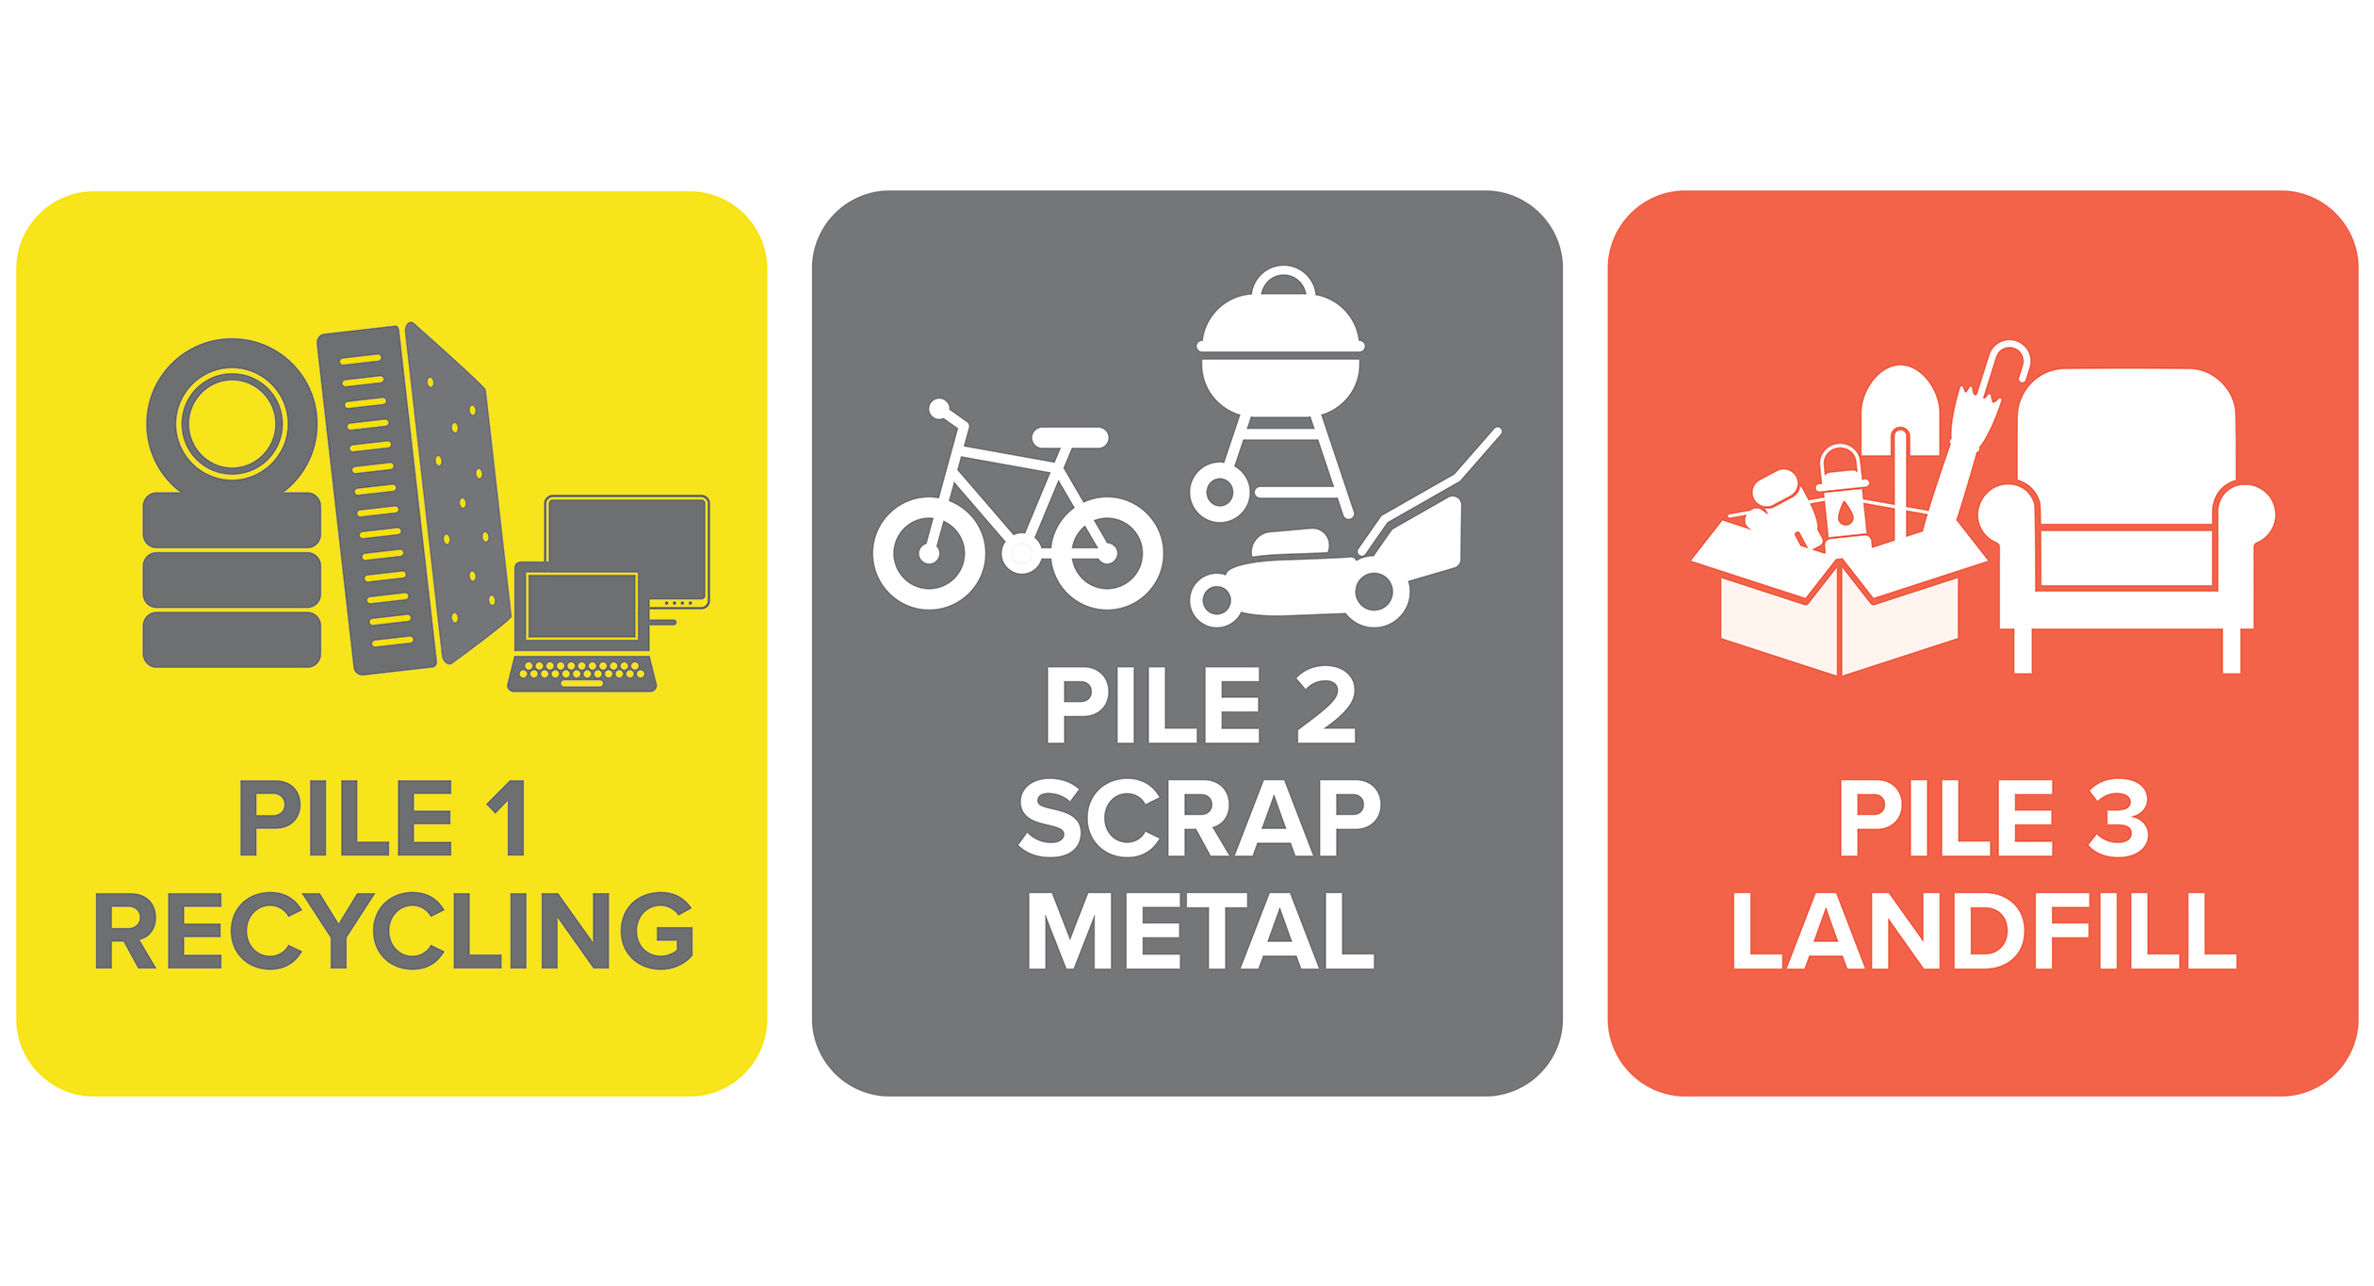

See Terms and Conditions on reverse for items accepted
and not accepted

I, Name
of Name of Organisation on this of
day month year
declare that I have the appropriate organisational authority and legal capacity to make representations and commitments on behalf of the owners of the above property for the purposes of arranging an On-Call Household Cleanup Service and making representations that may result in financial obligations on the property and/or occupants of the property. I confirm that I have fully read, understand
and unconditionally accept the Service Terms and Conditions and that all information on this form is true and correct. I also undertake to carry out the required actions of an Authorised Officer/Representative as set out in the Terms and Conditions.
Signature  | Date
Please return the completed and signed form to either:
Post:  REMONDIS Harbour Cities PO Box 341  UNANDERRA NSW 2526 | Email:  cleanup@wollongongwaste.com.au | 
Terms and Conditions

ON-CALL HOUSEHOLD CLEANUP COLLECTION - UNIT COMPLEX BOOKING CONSENT FORM

FORM

- The unit complex shall be entitled up to the maximum volumetric collection capacity each financial year - 2 x 2m3 cubic metres per unit (4m3 in total per unit). In the event that the Contractor is unable to provide the maximum volume entitlement in a single collection day, then the complex shall be entitled to book further collection days as required to provide up to the maximum collection capacity. Strata Managers can contact REMONDIS Harbour Cities to discuss individual collection requirements.
- The unit complex Authorising Officer/Representative will work co-operatively with REMONDIS Harbour Cities to agree on the collection bin number(s), size and collection point(s) at a unit complex where required.
- REMONDIS Harbour Cities will require unobstructed access to the property for the purpose of delivering, placing and collecting approved collection receptacles. For any logistical issues, please contact REMONDIS Harbour Cities direct on 1300 362 360 before completing your booking.

- The Property Owner and or Authorising Officer/Representative shall be responsible to advise occupants of the property of the agreed dates of collection and any logistical requirements, and to distribute the Contractor provided information brochure detailing the service to the property dwellings and occupants.

- The Property Owner and or Authorising Officer/Representative shall not allow any persons or organisations that are not a domestic or residential occupant of a dwelling to utilise the Cleanup services provided. Commercial businesses shall not be permitted to access the service.
- The Property Owner and or Authorising Officer/Representative indemnifies and releases Council and REMONDIS Harbour Cities from any claims, losses or damages resulting from damage to any driveways, pavements and or hard stands caused from heavy rigid vehicles that may be required to access the property to provide the services. The indemnity shall only cover damage created by the weight of the vehicle(s) and its contents being borne on the property’s access ways. The indemnity shall not extend to damage caused by the direct collision of the REMONDIS Harbour Cities vehicle with any private property within, or thereabout, the property.
- The Property Owner and or Authorising Officer/Representative shall be fully responsible for the management of, and to cover any costs or expenses associated with, the proper disposal of all non-acceptable materials, excessive materials above the authorised volumetric capacity provided by Council, and materials not contained within the bins provided, that may be presented by the complex residents and not collected by REMONDIS Harbour Cities.
- Any commercial arrangements between REMONDIS Harbour Cities and the Property Owner or Authorising Officer/ Representative shall remain commercial arrangements between those parties. At no time shall Council become liable for costs associated with any commercial arrangements made by the Property Owner and/or Authorising Officer/Representative and the REMONDIS Harbour Cities.
